Chancellors

1. Director : Prof. Dra.Yenni Rozimela, M.Ed.,Ph.D.

2. Vice Director I : Prof. Dr. Atmazaki, M.Pd.

3. Vice Director II : Prof. Dr. Dedi Hermon, M.P.

4. Study Program Coordinator : Prof. Dr. Ahmad Fauzan, M.Pd.,M.Sc.

Doctoral Program in Education Sciences

* The implementation of the Doctoral Program in Education Sciences, Postgraduate, Padang State University commenced in 2003 with the issuance of the Directorate General of Higher Education Decree No. 940/D/T-2003.
* Doctoral Program in Education Sciences, Postgraduate, Padang State University has produced 195 Doctoral of Educational Sciences, which have been dispersed across Indonesia.
* Currently, the Doctoral Program (S3) in Education has been accredited B by the Directorate General of Higher Education Decree No. 395/SK/BAN-PT/Ak-PPJ/D/I/2022 dated January 18, 2022.



* Starting from the 2017/2018 academic year, there has been Doctoral Program in Education Sciences **BY RESEARCH**.

Vision

**Becoming a dignified and internationally reputable postgraduate in a multidisciplinary field**

Mission

1. Organizing high-quality education and learning in multiple disciplines;
2. Conduct multidisciplinary research to generate innovation.
3. Using research findings to improve educational quality and community well-being;
4. Putting in place high-quality postgraduate governance;
5. Organizing fruitful and relevant collaborations with scientists from various disciplines

Lecturers

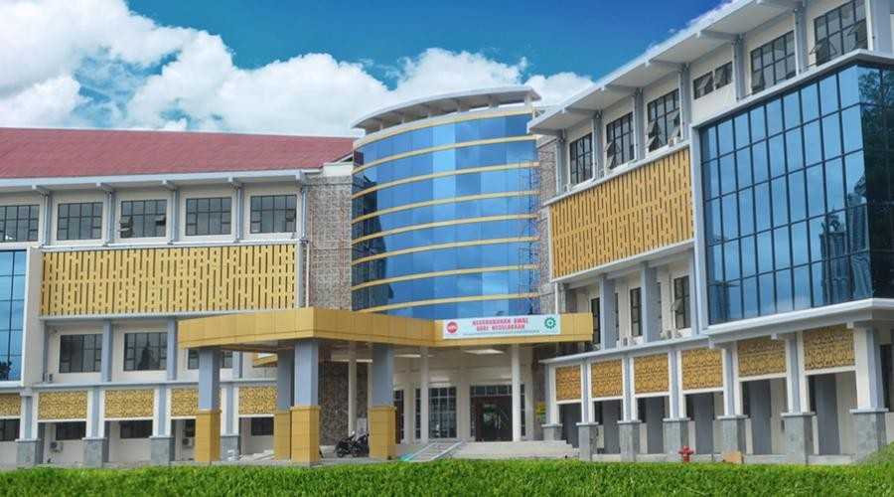

1. Prof. Nurhizrah Gistituati, M.Ed., Ed.D.

2. Prof. Dr.H.A. Muri Yusuf, M.Pd.

3. Prof. Dr. Z. Mawardi Effendi, M.Pd.

4. Prof. Dr.Phil Yanuar Kiram

5. Prof. Ganefri,Ph.D.

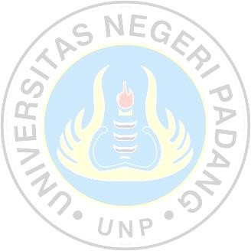6. Prof. Dr.H. Prayitno,M.Sc.Ed.

7. Prof. Dr.Azwar Ananda,MA.

8. Prof. Dr. Mukhaiyar

9. Prof. Dr. Rusdinal, M.Pd.

10.Prof. Dr.H. Sufyarma Marsidin, M.Pd.

11.Prof. Dr.M. Zaim, M.Hum

12.Prof. Dr.Gusril,M.Pd.

13.Prof. Dr.Jamaris Jamna,M.Pd.

14.Prof. Dr.Hasanuddin WS.,M.Hum.

15.Prof. Dr.H. Syahrul R.,M.Pd.

16.Prof. Dr.Atmazaki,M.Pd.

17.Prof. Dr.Lufri,M.S.

18.Prof. Dr.Festiyed,M.S.

19.Prof. Dr.Ahmad Fauzan,M.Pd.,M.Sc.

20.Prof. Dr.Jufrizal,M.Hum.

21.Prof. Dr.Hermawati Syarif,M.Hum.

22.Prof. Dr.Harris EffendiThahar,M.Pd.

23.Prof. Dr.Syafri Anwar,M.Pd.

24.Prof. Dr.Mudjiran,M.S.,Kons.

25.Prof. Dr.H.Agus Irianto

26.Prof. Dr.Eri Barlian,M.Si.

27.Prof. Dr.Neviyarni S.,M.S.

28.Prof. Dr.Ellizar,M.Pd.

29.Prof. Ali Amran,M.Pd.,M.A.,Ph.D.

30.Prof. Dr.Ermanto,M.Hum.

31.Prof. Dr.Agustina,M.Hum.

32.Prof. Dr.Herman Nirwana,M.Pd.,Kons.

33.Prof. Dr.Agusti Efi,M.A.

34.Prof. Dr.Alwen Bentri,M.Pd.

35.Prof. Dr.Daharnis,M.Pd.,Kons.

36.Dr. Marjohan,M.Pd.,Kons.

37.Dr. Jasrial,M.Pd.

38.Dr. Darmansyah,M.Pd.

39.Dr. Khairani, M.Pd.

40.Dr. Ishak Aziz,M.Pd.

41.Dr. Yuni Ahda,M.Si.

42.Dr. Latisma Dj.,M.Si.

43.Dr. Armiati,M.Pd.

44. Dr. Yulkifli,M.Si.

**Open Enrollment**

**DOCTORAL PROGRAM IN EDUCATION SCIENCES**

**POSTGRADUATE**

**PADANG STATE UNIVERSITY**

**ACADEMIC YEAR 2022/202399**

**B Accredited**

**(National Accreditation Board for Higher Education)**

**Postgraduate Campus of Padang State University**

Jln. Prof. Dr. Hamka Kompleks UNP

Air Tawar Padang 25131

Phone No.(0751)7051147 Facs.(0751)445088

Website: [http://pps.unp.ac.id.](http://pps.unp.ac.id)

Email: pascasarjana[.unp@gmail.com](mailto:unp@gmail.com)

TU_PPSUNP

yy

Enrollment Procedure

Online enrollment starts **March 1st** and ends **June 30st 2022** with the following requirements:

1. Fill out your biodata (name, mobile number and date of birth) on the website <http://spmb.unp.ac.id/pps> to obtain an account number, the amount of enrollment fee, as well as a User Id and PIN;

2. Pay the enrollment fee of IDR 600,000 (six hundred thousand rupiah) through a Bank Nagari teller or transfer via all ATMs (Bank Nagari, ATM Bersama, and ATM Prima);

3. Complete the enrollment form on the website <http://spmb.unp.ac.id/pps> in order to obtain registration verification (registration card);

4. Downloadable instructions for completing the enrollment form are available at <http://spmb.unp.ac.id/pps>.

Selection & Selection Results

Prospective students are **selected** by creating a Pre-Proposal Dissertation Framework Portfolio using the Postgraduate's provided template.

The **results of the selection** examination will be announced on the official UNP registration website on **July 15, 2022**. http://spmb.unp.ac.id , Padang State University Postgraduate *website*  UNP http://pps.unp.ac.id.

Re-Enrollment, Tuition & Courses

**RE-ENROLLMENT**

Re-registration/Registration for prospective students who have passed from **18 July to 22 July 2022**.

**TUITION**

Tuition Fee IDR 10,000,000

Education Development Fee

IDR 2,000,000 (one-time fee).

**COURSES**

Courses will be started on **August 8, 2022**.

Requirements

**General Requirements:**

1. Prospective students with a Master in Education or a Master in a field other than Education.

2. Minimum GPA of 3.00 on a scale of 4 from a National Accreditation Board for Higher Education accredited master's degree program.

**Specific Requirements for By Research Doctoral Students:**

1. Graduates of a master’s program with a GPA of 3.25.
2. Submit an application to the Postgraduate Director / Dean of the Faculty via the relevant Study Program Coordinator, including the following materials:
3. Photocopies of certificates and transcripts of Masters values that have been legalized 2 pieces.
4. List of research history, both independently and in groups, and include at least one article relevant to the intended study program that has been published in an accredited national journal or one scientific work published in an international journal within the last five years as independent work or as the primary author. (Requests for research history format can be made at Postgraduate UNP).
5. Recommendations from two doctoral-level lecturers with relevant expertise (The recommendation format can be requested from the Postgraduate UNP).
6. Research proposal for dissertation (The pre-proposal format can be requested from the Postgraduate UNP).

Additional Information

1. Ranks 1, 2, and 3 of the graduates of the Master's Program at Padang State University can continue to the Doctoral Program without a test, but still follow the enrollment procedure.
2. If there are at least 6 students, orientation on the Doctoral Program (S3) in Education Sciences is opened.
3. Time, location, and information about the implementation of the selection can be found on the UNP and Postgraduate websites.
4. Prospective students who meet the requirements can apply for the LPDP Scholarship or the Indonesian Lecturer Excellence Scholarship (BUDI-DN). Information can be found on the Directorate General of Higher Education website.

Curriculum

**A. Curriculum By Course (42 credits):**

**- Courses 2 Semester**

**- Education Sciences Courses 24 credits**

**- Orientation Courses and Dissertation 18 credits**

**B. Curriculum By Research (42 credits):**

**- Courses 1 Semester**

**- Education Sciences Courses 12 credits**

**- Orientation, Publication, and Dissertation 30 SKS**